**PRACTICAL NO : 04**

**Title :** Design and develop custom Application (Mini Project) using Salesforce Cloud.

STEPS TO CREATE AN APPLICATION(mini project) :

1. Open salesforce in Lightning Experience.
2. Open App Launcher → View all → Quick Search → App Manager → Click on New Lightning App.

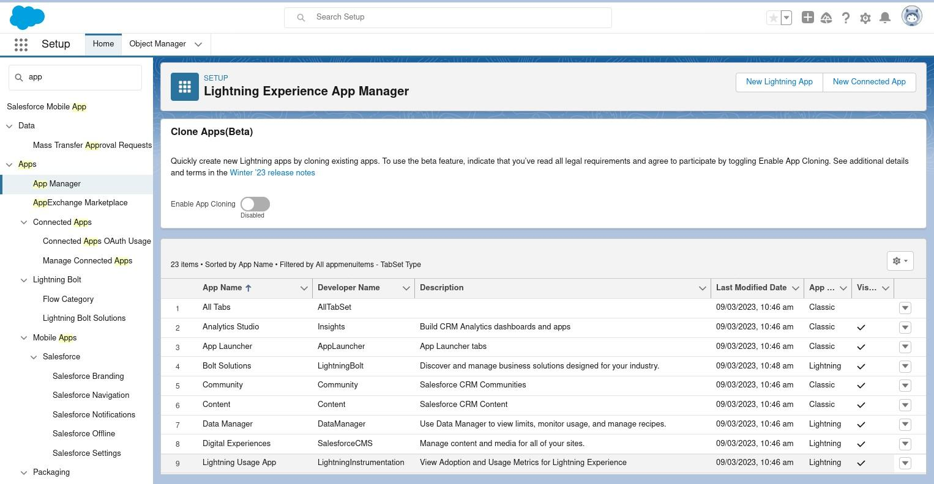

1. fill the mention information.

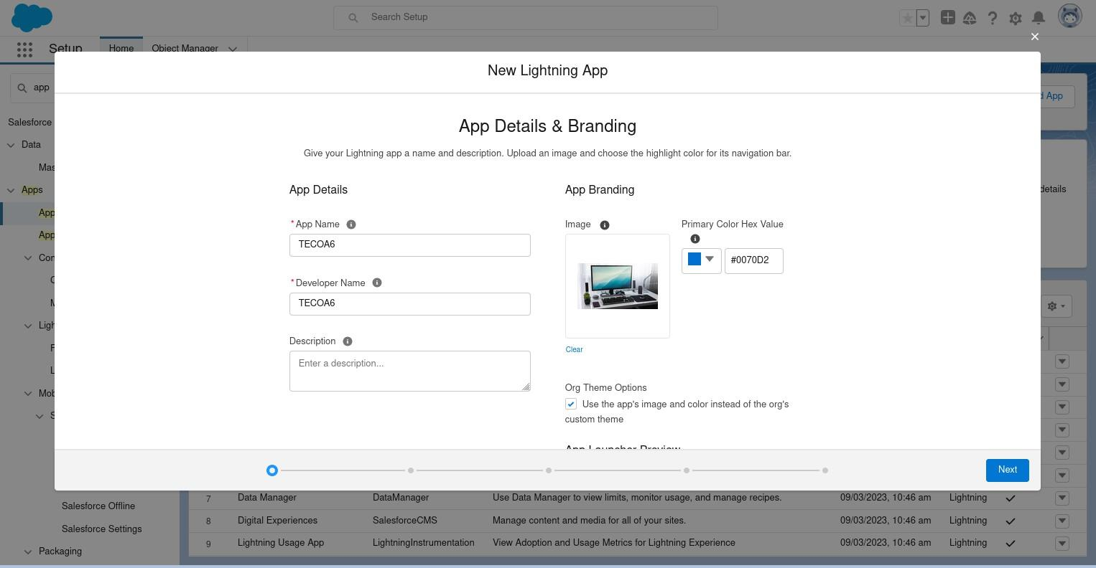

1. Next → App option(optional ).

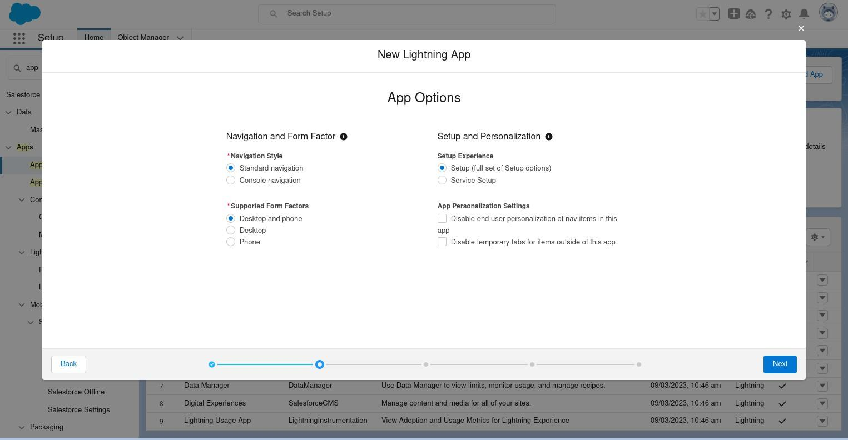

1. Next → Add Utility (optoinal).

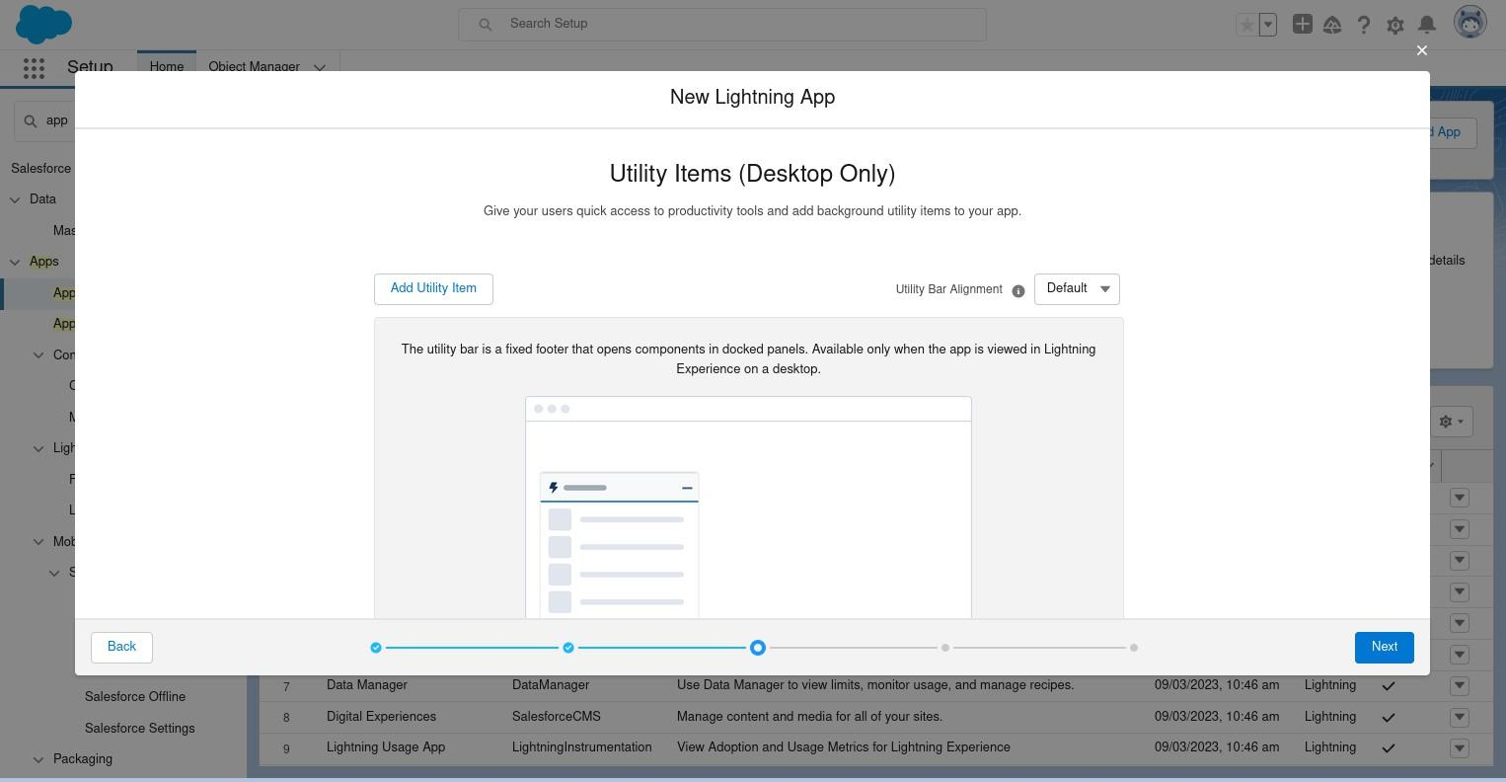

1. Next → Navigation Item(you can add item).

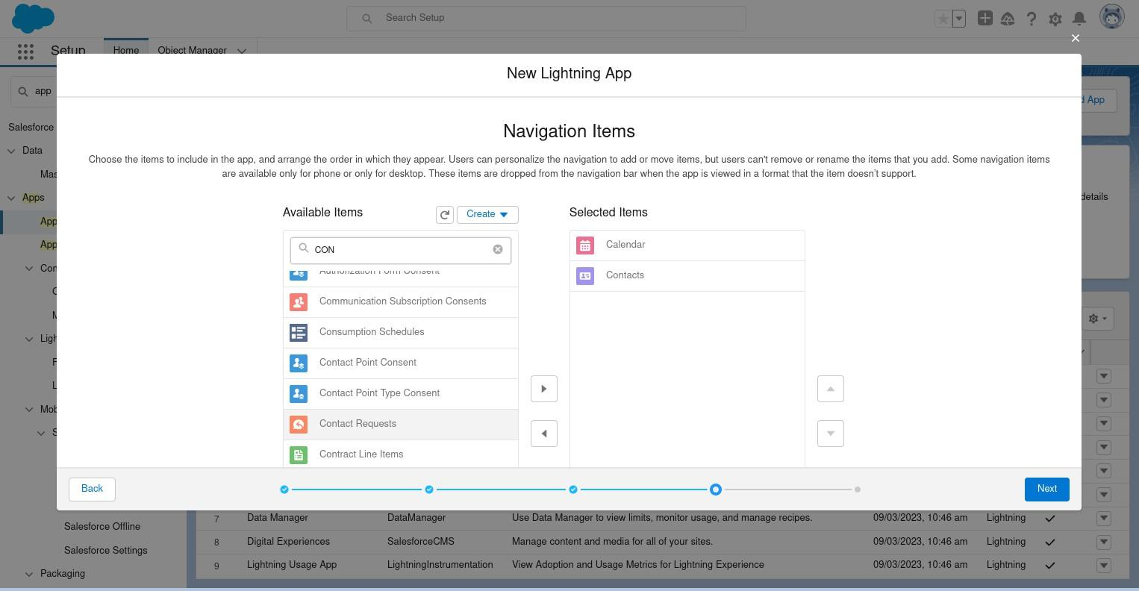

1. Next → User Profile(use the user profilethat can access this app) → Save and Finish.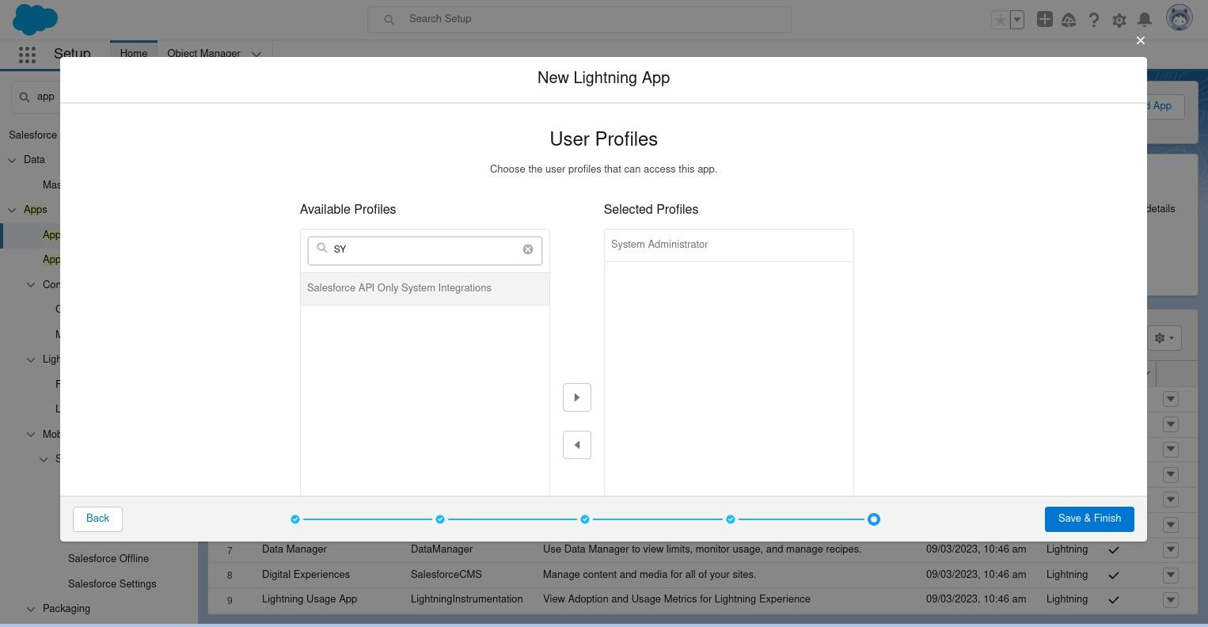
2. You will get Lightning Experience App Manager Window.

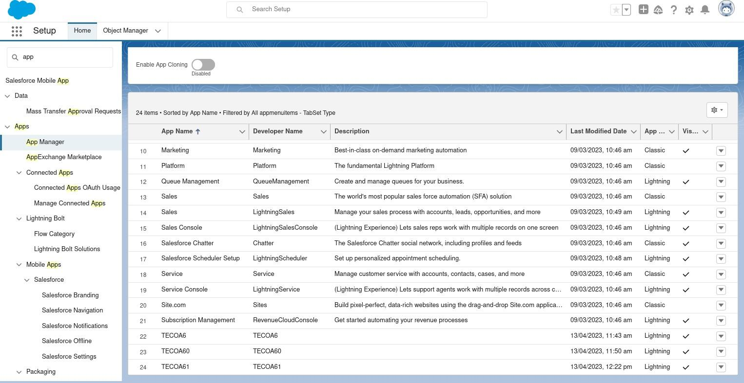

1. Search Your App by its name in App Launcher.→ just by entering some character, you can see app name with its logo.

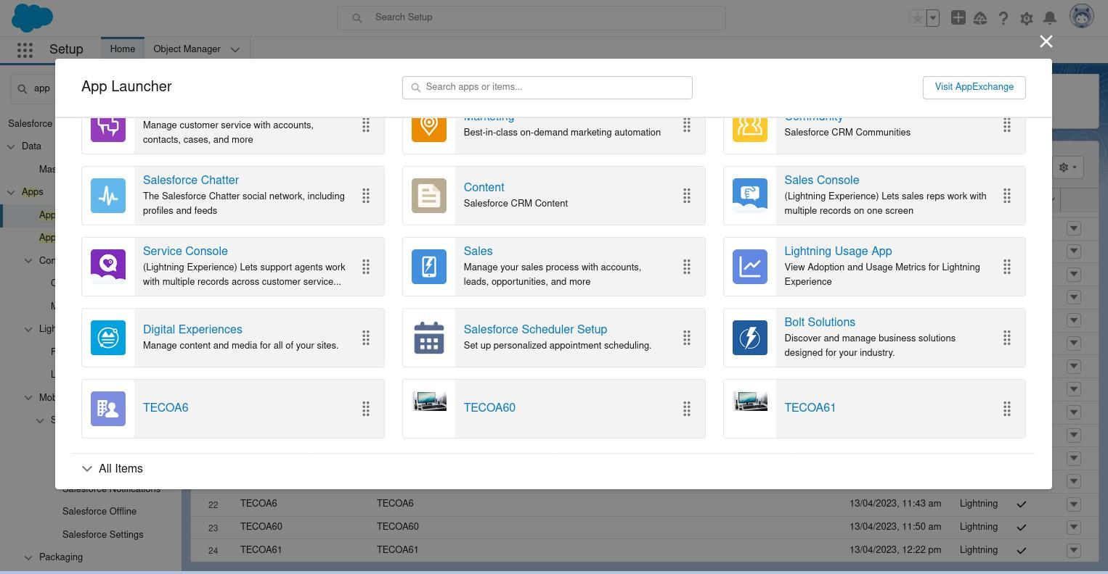

1. Click on App → you can see your application appearance in window → Output.

